MVC4

# PAGing

Add more a package

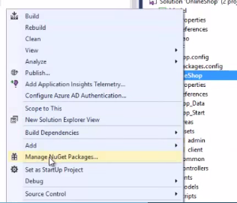

Search Pagelist to install

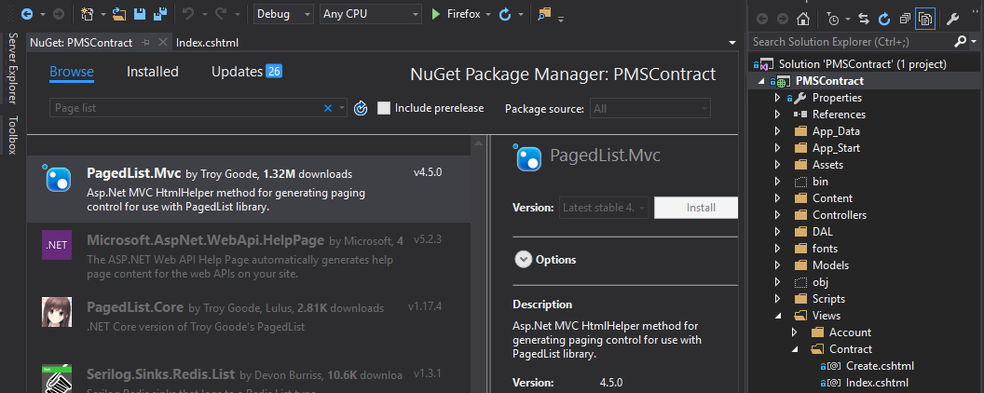

# using the layout temlate

Create an Assets folder

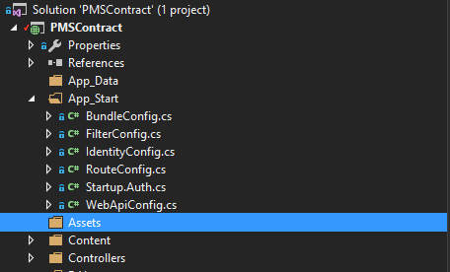

Copy source AdminLTE2 into Assets folder

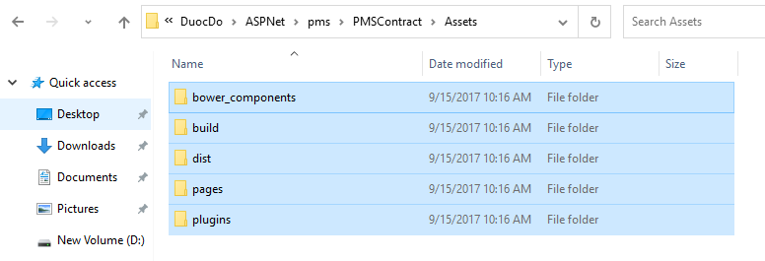

Create a _LayoutAdminLTE.cshtml on Views folder

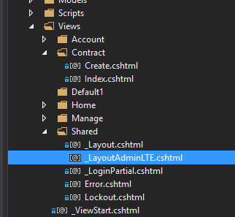

And then copy all source html into _LayhoutAdminLTE.cshtml and change something about links

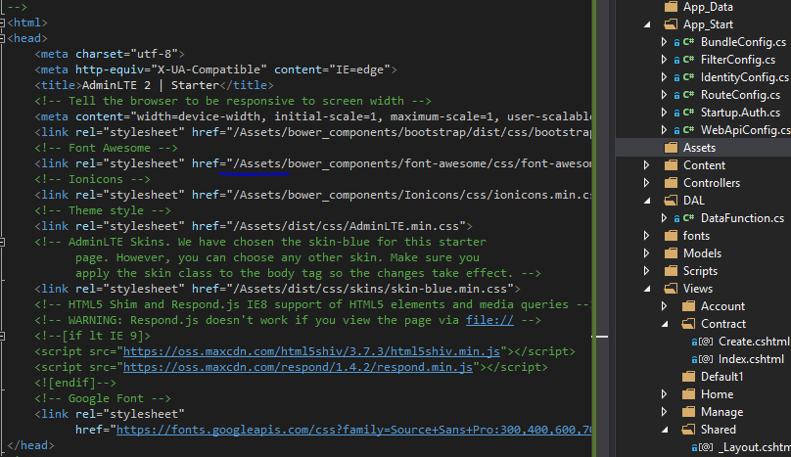

@RenderBody() // On master page

@RenderSection(“Varible_Name”,True or False) // On master page.

@section Varible_Name { HTML code in here …} // On children page, can put it anywhere.

# NOTES

Namespace chính là đường link của Model or Controller

# razor

<a href=”@Url.Action(“tenfile”,”TenFolder or Controller name”) title=”read our blog”>Read our blog</a> // apply for main menu

or <li> @Html.ActionLink(“Content text”,”tenfile”,”Folder link or Controller name”,”a route data object with default Null”, new { attribute ex: title=”Click here”})

@{ Layout-“_Layout”;}  
@RenderBody()  
@RenderSection()  
@select any_name{ }  
@select header{ }  
@Html.DropDownListFor(m => m.StudentGender,

new SelectList(Enum.GetValues(typeof(Gender))),

“Select Gender”)

RadioButton (string name, object value, bool isChecked, object htmlAttributes) ex: @Html.RadioButton(“Gender”,”Male”); @Html.RadioButton(“Gender”,”Female”)

@RadioButtonFor(<Expression<Func<TModel,TValue>> expression, object value, object htmlAttributes)

@TextAreaFor(<Expression<Func<TModel,TValue>> expression, object htmlAttributes) ex: @Html.TextAreaFor(m=>m.Description, new{@class=”form-control”})  
@TextBoxFor(Expression<Func<TModel,TValue>> expression, object htmlAttributes) ex: @Html.TextBoxFor(m => m.StudentName, new { @class = “form-control” })  
FIX WARNING FOR PACKAGES: <packages xmlns="urn:packages">

This is the link for the fairy tale:  <http://www.online-literature.com/wilde/176/>

I would like to read this story, it is a sad story with the moral of a story. I really love this story. It makes me many problems to think like "We should know how to keep and respect good things or do not skip good mentions". I hope I have a good relationship with everyone around me.

Special, I will take note this sentence from the story in my mind "You will never be in the best society unless you can stand on your heads"

Thank you so much for checking!

**PASS DATA FROM THE CONTROLLER TO THE VIEW (CONTROLLER - VIEW)**From file in Controller:  


From a file in View  


**Render data with strongly typed views (Model – (Controller and Views))  
+ on Model file  
  
+ on Controller file**

**CÁCH EXPORT DỮ LIỆU TỪ BÊN MODEL NHANH VÀO CONTROLLER FILE NHƯ HÌNH BÊN DƯỚI**



**hoặc gõ như hình sau**



**+ on Views file**



**REUSE VIEW MARKUP WITH PARTIAL VIEWS**

**+ Create a file on share folder with partial view property   
**

**named _Post.cshtml  
**

**Put the code on _Post.cshtml is @Html.Partial (“namefile”)  
**

**Finally, open a need file to use it and call @Html.Partial(“namefile”);**



# route

[Route(“path link”)] ex: [Rout(“”)], [Route(“Blog”)], [Route(“{year:min(2000)}/{month:range(1,12)/{key}}”]

# SCROLL PAGing

<https://ricardodsanchez.com/infinite-scroll-with-asp-net-mvc/>

# NEED TO KNOW

Ke thua lop thu vien Controller trong MVC

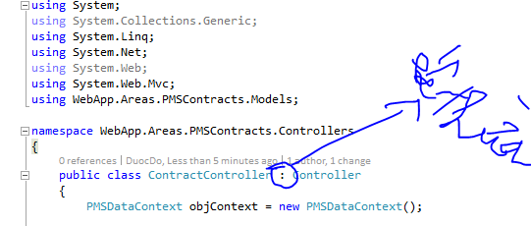

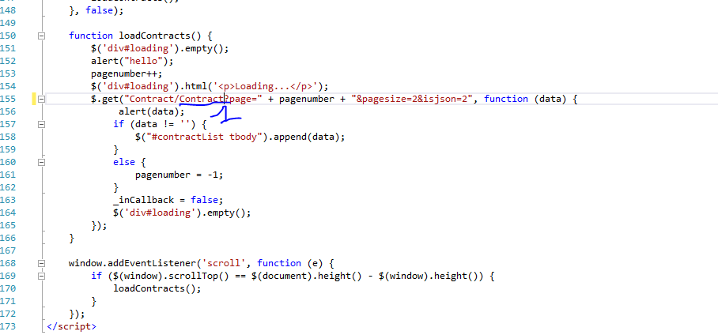

1: ham trong function cua Controller  
KHI TAO MOT MODEL FILE MOI THI CAN PHAI KHAI BAO TRONG CONTEXT DATABASE

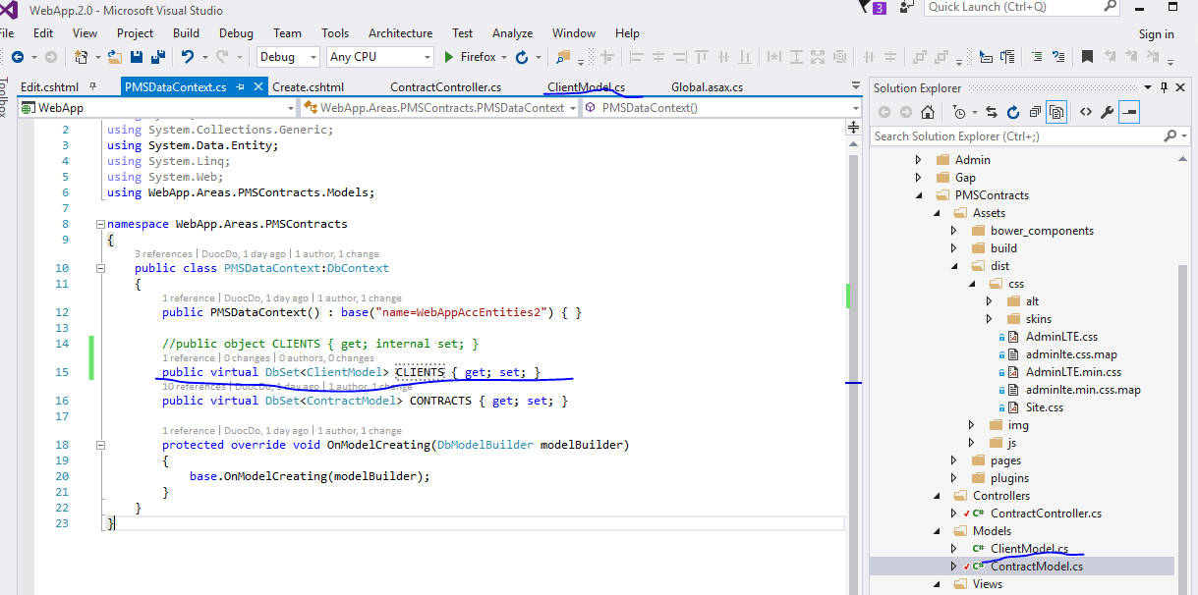

KHI TAO FILE MODEL CAN LUU Y 3 VDE SAU:

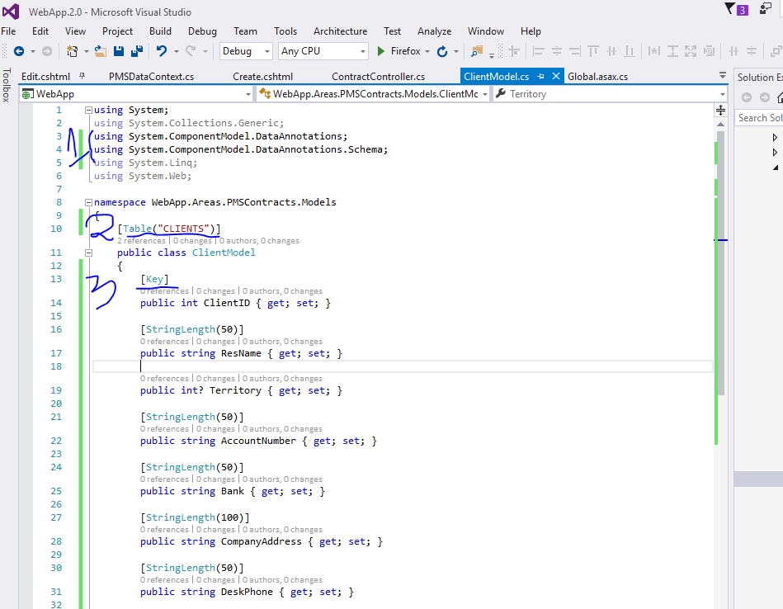

1: thu vien / 2: table name (put any name) / 3: key for field

# PAGing

sfssdfdsfsfssdssf

# PAGing

Add more a package